***ABOUT:***

**VINSTEAM ENGINEERING** has more than four years of experience in MEP Projects including design and execution as best engineering services to Commercial, Pharmaceutical and Engineering Industries.

We have an in-house design team at VINSTEAM ENGINEERING to offer optimized and effective solutions to our clients, through our Sales and Project team. Our design team will also work based on the costumer requirement. We have certified field technicians experienced in Turnkey MEP projects.

We have a strong project management team which excels in providing new facilities & modifications for Commercial, Pharmaceutical and Engineering Industries. Our teams primary focus is offering customer centric design solution with end to end management.

Our main line activities are Turnkey projects, MEP projects, Industrial and Commercial fire fighting systems, Underground Water Pipe Line and Drainage systems including design and execution.

***VISION :*** **To be a company driven by its passion for excellence and continuously endeavour to complete every project absolutely in line with the scope of work providing complete satisfaction to our customers and our team.**

***MISSION:***

To sustain and improve the competitiveness and capabilities of our customers through excellence in engineering and to provide complete range of services and solutions while ensuring quality,compliance, efficiency, cost and environment.

***OUR VALUES :***

* Quality Workmanship
* Code of Ethics & Corporate Governance
* High Safety Standards
* Customer satisfaction

***Services:*** VINSTEAM ENGINEERING provides turnkey solutions covering the complete execution of projects from conceptual designs to commissioning that include all activities.

* **Fire Fighting System:** Designing and Execution of Industrial and Commercial Fire Fighting Systems including Fire Alarm and GAS detecting systems as per the ISO guidelines.
* Turnkey Project Design and Execution along with the specifications write up, conceptual design drawings, followed by above services.
* Technical Support onsite/offsite for above systems.
* We offer our services to end-users, clients etc. We provide all the above related services to any new systems as well as modifications.
* **MEP Projects:**  Design and Engineering Services in the area of MEP to a wide range of**HVAC, Plumbing, Fire Fighting, Electrical and Installation Inspection services**. We provide value addition to the benefit of customer in all that we do

. We offers the following integrated MEP services

* Design, detailed engineering, manufacturing, procurement, project management, installation, testing, commissioning.
* Design and execution of electrical contracting projects.
* Design and execution of plumbing and Fire Fighting Systems.
* Design & Execution of Structural Roofing ,Grills, Structural Pipe racks, SS and MS Railing etc. for commercial & industrial purposes
* **Utility & Services:** Compressed Air systems, Underground water pipe line and drainage systems, Hot water systems, chilled water and cooling water pipe lines design and execution.

**Project Management Services:** We take up projects on turnkey basis and provide end to end solutions from planning till commissioning of Project. Our Team is highly dedicated professionals with project management skills with Conduct Professional site reviews, provide best Cost & Time estimates based WBS / Critical Task Analysis, Optimized resource allocation with assured material availability & time bound project execution. More than four years of experience each are working exclusively for turnkey projects

We offers the following Project planning service

* Project Scheduling
* Layout design
* Process & Instrumentation diagram
* Pipeline Supports Design
* Isometric drawings
* Bill of materials
* Execution
* Monitoring and controlling
* Closing

**Our Expertise:**

* **MEP projects Consulting, Planning & Designing**
* **FIRE Fighting system Installation, Testing & Commissioning**
* **Utility projects Installation, Testing & Commissioning**

***OUR MAJOR PHARMA CLIENTS :***





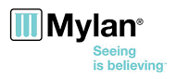

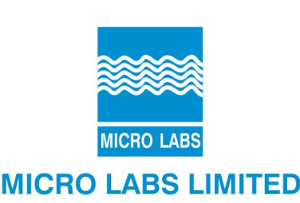

***CONTACT US :***

**ADDRESS**

*VINSTEAM ENGINEERING*

*G-5, 2nd Floor, 2nd cross, Muniyyapa Building,*

*Chikkathogur Main Road, Electronic City,*

*Bangalore-560100*

**QUICK CONTACT**

*Mobile 1: +91-7760077355*

**EMAIL ADDRESS**